Add Additional Elevation (Freeboard) above the minimum BFE + 1 foot required by the 6th. Ed. FBC – FPM ordinance text changes and local technical code amendments (FBC, R and FBC, B)

NEW REQUIREMENTS IN 6th Ed. FBC! The 6th Edition FBC requires all buildings to be elevated to or above the Base Flood Elevation (BFE) plus 1 foot. The requirement is new to the FBC, Residential. The FBC, Building has required a minimum of BFE + 1 ft since 2010.

CRS Note. With all communities now required to enforce the FBC with BFE + 1 ft, CRS credit should be available to those communities that did not previously adopt at least BFE + 1 ft. See guidance prepared by DEM to help CRS communities satisfy the CRS/ISO documentation related to the FBC and freeboard requirements (link below).

Description: Elevating buildings higher than the minimum base flood elevation required by the NFIP reduces the frequency and severity of flood damage. Reflecting that reduction, NFIP flood insurance premiums are lower for individual buildings that are elevated above the minimum BFE (see graphic). An independent study conducted for FEMA determined that the incremental cost of additional elevation can be offset within a few years (depending, of course, on a number of factors such as foundation type; elevation on fill tends to be the most expensive method of elevation). See the last page for additional reasons to consider elevating buildings higher than the minimum requirement.

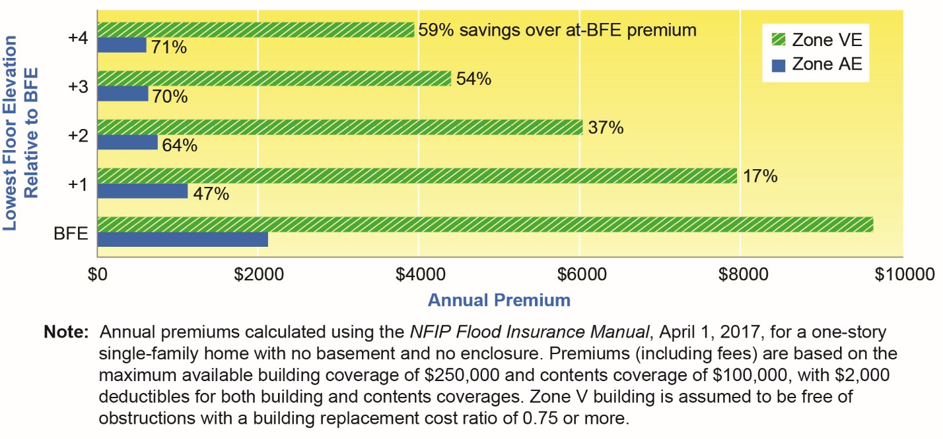

How the 6th Ed. FBC, Building specifies BUILDING elevations: The FBC, B does not specify building elevations in the body of the code. Rather, it is done by reference to ASCE 24 which requires buildings within the scope of the FBC, B to be above the BFE as a function of flood zone and risk category. To see the existing elevation requirements in ASCE 24, see the summary table of elevation requirements in “Highlights of ASCE 24” available at State Floodplain Management Office's website at: https://www.floridadisaster.org/dem/mitigation/floodplain/ (Community Resources). Note that higher elevations are required for the more important buildings: Flood Design Class 3 and Flood Design Class 4 buildings are required to be elevated higher than Flood Design Class 2 buildings, and Flood Design Class 2 buildings are required to be elevated higher than Flood Design Class 1 buildings. Flood Design Class 1 buildings “represent a low hazard to human life in the event of failure, including but not limited to agricultural facilities, certain temporary facilities, and minor storage facilities.” The majority of buildings are Flood Design Class 2.

To determine the elevation requirement for a specific building within the scope of the FBC, B, the designer (and code official) must first determine the flood zone and the Flood Design Class of the building (required by Sec. 1603.1.7), and then use the tables in ASCE 24 to determine the minimum required elevation of the lowest floor (Zone A) or lowest horizontal structural member of the lowest floor (Zone V and Coastal A Zone).

Note that State agency regulations are incorporated into the FBC for hospitals (Sec. 419), nursing homes (Sec. 420), and educational facilities (Sec. 423). Sec. 419 and Sec. 420 already require BFE + 2 ft or the height of hurricane Category 3 surge inundation elevation, whichever is higher. Sec. 423 requires compliance with ASCE 24 (with relocatable units elevated to BFE + 1 ft).

How the 6TH Ed. FBC, Residential specifies BUILDING elevations: The FBC, R is prescriptive. The minimum elevations are specified in the 6th Edition FBC, R Sec. R322 and are based on flood zone:
- R322.2.1 (Zone A) specifies the elevation of the lowest floor is at or above the BFE + 1 ft.
- R322.3.2 (Zone V and Coastal A Zones) specifies elevation of the lowest horizontal structural member is at or above the BFE + 1 ft.

How the 6th Ed. FBC specifies FLOOD elevations in “approximate Zone A” without BFEs. FBC, B, Sec. 1612.3.1 specifies that where the design flood elevation (DFE) (which is the same as the BFE in communities that use FEMA’s FIRMs) is not specified, the building official may require use of data from other sources or may require the applicant to determine the DFE. Similarly, FBC, R Sec. R322.1.4.1 specifies that where DFEs/BFEs are not specified, the building official may require use of data from other sources or may require the applicant to determine the DFE. Also see Sec. 105.2 of the Model Floodplain Management Ordinance (or locally adopted regulations) titled “Information in flood hazard areas without base flood elevations (approximate Zone A),” which is consistent with the FBC.

If data from another source are not available, that section of the ordinance specifies the Floodplain Administrator may require the applicant to develop BFE data. Alternatively, the Floodplain Administrator may assume the BFE is not less than 2 ft above the highest adjacent grade at the building footprint – provided there is no evidence indicating flood depths have been or may be greater. This “default” to just 2 ft above grade is allowed by FEMA policy, but should not be used to circumvent knowledge of hazards in every approximate Zone A. If a community wishes to increase the default elevation, additional height may be added here. This is not the same as freeboard, which is done by modifying the requirements that specify how high the lowest floor is relative to the flood elevation.

INSTRUCTIONS
Submit your draft ordinance (in <track changes>) to Technical Support flood.ordinance@em.myflorida.com for review well in advance of your first reading.

Adopting freeboard higher than the FBC minimum requires modifying both the FBC, Residential and the FBC, Building, resulting in all buildings being elevated to BFE + 2 ft or higher. These instructions also apply for other increments, such as 18 inches or 3 feet.

Step 1. See the General Instructions. Choose the appropriate Whereas clause identified in Step 1 of the General Instructions. If your community already has freeboard or you are adopting it for the purpose of participating in the CRS, insert the following brief description of the higher standard in the appropriate whereas clause:

increase the minimum elevation requirement

Step 2. In SECTION 2 of the ordinance package (which contains the floodplain management regulations), modify language for Sec. 304.6 (certain existing manufactured homes). Change the minimum foundation height from 36 inches to 60 inches. Communities may choose NOT to do this, but it is important to realize that omitting freeboard for these “certain” manufactured homes will mean the intended added level of safety and damage reduction afforded by freeboard is not uniformly imposed (and may result in fewer CRS points for freeboard).

304.6 Elevation requirement for certain existing manufactured home parks and subdivisions. Manufactured homes that are not subject to Section 304.5 of this ordinance, including manufactured homes that are placed, replaced, or substantially improved on sites located in an existing manufactured home park or subdivision, unless on a site where substantial damage as result of flooding has occurred, shall be elevated such that either the:
- Bottom of the frame of the manufactured home is at or above the elevation required, as applicable to the flood hazard area, in the Florida Building Code, Residential Section R322.2 (Zone A) or Section R322.3 (Zone V); or
- Bottom of the frame is supported by reinforced piers or other foundation elements of at least equivalent strength that are not less than 60 inches 36 inches in height above grade.

Step 3. Add a new SECTION 3 to the ordinance package to adopt local technical amendments to the FBC, Building as follows. Maintain strikethrough and underlining to denote changes to the FBC.

SECTION 3. {Insert citation for current chapter Buildings; insert appropriate section number) is hereby amended by the following technical amendments to the Florida Building Code, Building.

1612.4.2 Elevation requirements. The minimum elevation requirements shall be as specified in ASCE 24 or the base flood elevation plus 2 feet (610 mm), whichever is higher.

Step 4. Add a new SECTION 4 to the ordinance package to adopt local technical amendments to the FBC, Residential as follows. Maintain strikethrough and underlining to denote changes to the FBC.

SECTION 4. {Insert citation for current chapter Buildings; insert appropriate section number) is hereby amended by the following technical amendments to the Florida Building Code, Residential.

R322.2.1 Elevation requirements.
1. Buildings and structures in flood hazard areas including flood hazard areas designated as Coastal A Zones, shall have the lowest floors elevated to or above the base flood elevation plus 2 feet 1 foot (305 mm), or the design flood elevation, whichever is higher.
2. In areas of shallow flooding (AO Zones), buildings and structures shall have the lowest floor (including basement) elevated to a height above the highest adjacent grade of not less than the depth number specified in feet (mm) on the FIRM plus 2 feet 1 foot (305 mm), or not less than 4 feet 3 feet (915 mm) if a depth number is not specified.
3. Basement floors that are below grade on all sides shall be elevated to or above base flood elevation plus 2 feet 1 foot (305 mm), or the design flood elevation, whichever is higher.
Exception: Enclosed areas below the design flood elevation, including basements with floors that are not below grade on all sides, shall meet the requirements of Section 322.2.2.

Note: Communities with only Zone A need not modify R322.3.2 because it applies in Zone V and Coastal A Zone, except some coastal communities may have Coastal A Zone delineated even if they do not have Zone V, in which case this amendment should be adopted.

R322.3.2 Elevation requirements.
1. Buildings and structures erected within coastal high-hazard areas and Coastal A Zones, shall be elevated so that the bottom of the lowest horizontal structure members supporting the lowest floor, with the exception of pilings, pile caps, columns, grade beams and bracing, is elevated to or above the base flood elevation plus 2 feet 1 foot (305 mm) or the design flood elevation, whichever is higher.
2. Basement floors that are below grade on all sides are prohibited.
3. The use of fill for structural support is prohibited.
4. Minor grading, and the placement of minor quantities of fill, shall be permitted for landscaping and for drainage purposes under and around buildings and for support of parking slabs, pool decks, patios and walkways.
5. Walls and partitions enclosing areas below the design flood elevation shall meet the requirements of Sections R322.3.4 and R322.3.5.

ADDITIONAL REASONS TO ADOPT ADDITIONAL ELEVATION (FREEBOARD).

- After flood events, buildings that are either above floodwater or only minimally flooded can be more quickly re-occupied, allowing people to get more quickly get back to their homes, businesses, and community.
- When people get back in their homes quickly, there’s less cost burden on government at all levels (and nonprofits) because less temporary housing and other emergency assistance is needed.
- When families and businesses get back more quickly, they more quickly begin spending money locally, thus helping local tax revenues get back to more normal levels.
- People not covered by flood insurance have to pay for repairs out of pocket or get Small Business Administration loans (which are not really “low” interest loans). When buildings are higher, owners are less likely to have to dip into savings or borrow to pay for repairs.
- Several FEMA studies estimated that nearly 1 in 4 small businesses damaged in disasters end up closing for good: build higher and better protected, stay in business.
- Freeboard can be a creditable element in a local floodplain management program that qualifies for the Community Rating System. Communities that participate in the CRS qualify for lower flood insurance premiums in most flood-prone areas.

