Coastal A Zone – Effect of the 6th Edition Florida Building Code and FPM ordinance text changes and local technical code amendments (FBC, R) to qualify for CRS credits (CAZ) and to locally designate a Coastal A Zone

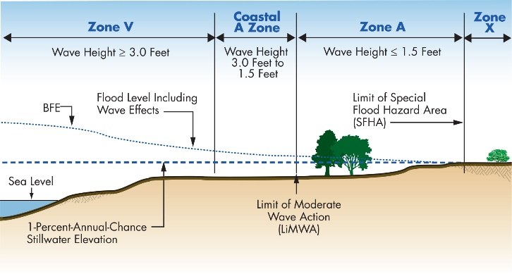
NEW REQUIREMENTS IN 6th Ed. FBC! The 6th Edition FBC requires Coastal A Zones (CAZ) to be regulated like Zone V under two circumstances: (1) if FEMA has delineated the Limit of Moderate Wave Action (LiMWA) or (2) if the community has designated the CAZ. Both the FBC, R (Sec. R322.3.3) and FBC, B by reference to ASCE 24 (ASCE Sec. 4.5.13) provide an exception to allow backfilled stem walls in CAZ, provided the foundations are designed for wave loads and account for scour. The FBC, Building has a Florida-specific section that permits dry floodproofing in CAZ (Sec. 1612.4.1) provided wave loads and scour are accounted for in designs. Also new to the 6th Ed. FBC, R, in all flood zones the minimum elevation is BFE + 1 foot.

BACKGROUND AND DESCRIPTION: Post-flood evaluations, engineering calculations and laboratory tests indicate that conventional construction sustains considerable damage when exposed to waves between 3 feet and 1.5 feet high. FEMA draws the inland boundary of the coastal high hazard area (Zone V) where analyses and modeling indicate waves will be less than 3 feet high during the base flood. The NFIP minimum requirements for buildings do not recognize the risk associated with waves less than 3 feet high.

Several years ago FEMA adopted a policy that new studies to revise maps in coastal communities would determine if areas are subject to waves between 3 feet and 1.5 feet. When those conditions are identified, FEMA will delineate the inland extent of the 1.5-foot wave as the Limit of Moderate Wave Action (LiMWA). See graphic on next page.
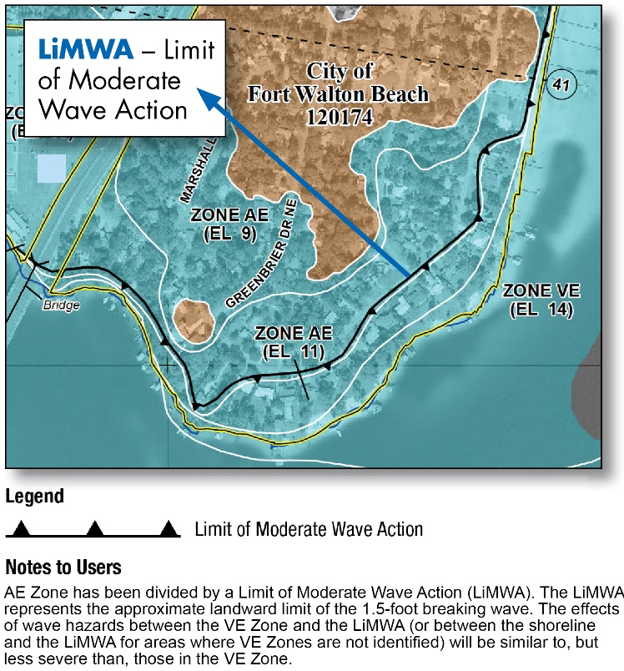
Although not labeled on FIRMs, these areas between the LiMWA and the Zone V boundary (or shoreline) are called “Coastal A Zones” (CAZ). FEMA Procedure Memorandum 50 on the decision to identify these areas as an informational layer on Flood Insurance Rate Maps is available online.

Keep in mind that even if a community’s current effective Flood Insurance Rate Maps do not show a LiMWA, the maps may be revised in the future as part of FEMA’s nationwide initiative to update FIRMs.

CRS Note #1. A prerequisite for CRS participation is retention of the LiMWA on FIRMs, if delineated by FEMA.

CRS Note #2. Up to 500 points are available to CRS communities that enforce Zone V requirements “inland from the V-Zone boundary.” However, according to the 2017 CRS Coordinators Manual, credit for regulating Coastal A Zones like Zone V is available only if all Zone V requirements apply. Thus, partial CAZ credit is not available based on the 6th Ed. FBC because of the exceptions that permit backfilled stem walls and dry floodproofing. To qualify for CRS credits for CAZ, communities must adopt local technical amendments to remove those exceptions. Instruction A below shows how to format those technical amendments.
Some Other Higher Standards (OHS) credit may be available if the backfilled stem wall and dry floodproofing provisions are retained. As of February 2018, DEM has not confirmed this with ISO/FEMA.

CRS Note #3. If FIRMs do not have FEMA-mapped LiMWAs, communities may designate “an equivalent [area] created with the same mapping criteria” (CRS Coordinator’s Manual, 432.k, page 430-33). Based on this statement, simple designation of an area, e.g., 500-feet inland of the A/V boundary, is not sufficient unless it can be demonstrated such designation incorporates areas subject to moderate wave action using the “same mapping criteria” FEMA uses. The FBC definition of “Coastal A Zone” refers to the LiMWA delineated by FEMA or “otherwise designated.” Instruction B below shows how to “otherwise designate” by adopting a local map of the CAZ or specifying the CAZ by physical dimensions. Also see Instruction A to satisfy the CRS requirement to apply all Zone V requirements within the designated area.

CRS Note #3. See guidance prepared by DEM to help CRS communities satisfy the CRS/ISO documentation related to the FBC and CAZ requirements. ADD LINK when we have it

INSTRUCTIONS.
Submit your draft ordinance (in <track changes>) to Technical Support flood.ordinance@em.myflorida.com for review well in advance of your first reading.

INSTRUCTION A. REMOVE STEM WALL AND DRY FLOODPROOFING EXCEPTIONS FROM THE FBC. Use this set of changes to remove the stem wall and dry floodproofing exceptions, resulting in application of ALL Zone V requirements to the Coastal A Zone.

Step A-1. See the General Instructions to select the appropriate Whereas clause(s). Insert the following brief description of the higher standard:

modify coastal high hazard area requirements for application in Coastal A Zones,

Step A-2. Prepare a SECTION in the ordinance to adopt local technical amendments to the FBC, Building as follows. Maintain strikethrough and underlining to denote changes to the FBC.

SECTION xx. {Insert citation for current chapter Buildings; insert appropriate section number} is hereby amended by the following technical amendments to the Florida Building Code, Building.

1612.4.1 Modification of ASCE 24. Reserved. Table 6-1 and Section 6.2.1 in ASCE 24 shall be modified as follows:
1. The title of Table 6.1 shall be “Minimum Elevation of Floodproofing, Relative to Base Flood Elevation (BFE) or Design Flood Elevation (DFE), in Coastal A Zones and in Other Flood Hazard Areas that are not High Risk Flood Hazard Areas.”
2. Section 6.2.1 shall be modified to permit dry floodproofing in Coastal A Zones, as follows: “Dry floodproofing of nonresidential structures and nonresidential areas of mixed-use structures shall not be allowed unless such structures are located outside of High Risk Flood Hazard areas and Coastal High Hazard Areas. Dry floodproofing shall be permitted in Coastal A Zones provided wave loads and the potential for erosion and local scour are accounted for in the design. Dry floodproofing of residential structures or residential areas of mixed-use structures shall not be permitted.”

1612.4.2 Modification of ASCE 24 (Coastal A Zone). Section 4.5.13 in ASCE 24 shall be modified as follows:
- Paragraph 1 shall be modified: “In Coastal High Hazard Areas and Coastal A Zones, stem walls shall not be permitted.”
- Paragraph 2 shall be deleted.

Step A-3. Prepare a SECTION in the ordinance to adopt a local technical amendment to the FBC, Residential as follows. Maintain strikethrough and underlining to denote changes to the FBC.

SECTION xx. {Insert citation for current chapter Buildings; insert appropriate section number} is hereby amended by the following technical amendments to the Florida Building Code, Residential.

R322.3.3 Foundations. Buildings and structures erected in coastal high-hazard areas and Coastal A Zones shall be supported on pilings or columns and shall be adequately anchored to such pilings or columns. The space below the elevated building shall be either free of obstruction or, if enclosed with walls, the walls shall meet the requirements of Section R322.3.4. Pilings shall have adequate soil penetrations to resist the combined wave and wind loads (lateral and uplift). Water-loading values used shall be those associated with the design flood. Wind-loading values shall be those required by this code. Pile embedment shall include consideration of decreased resistance capacity caused by scour of soil strata surrounding the piling. Pile systems design and installation shall be certified in accordance with Section R322.3.6. Spread footing, mat, raft or other foundations that support columns shall not be permitted where soil investigations that are required in accordance with Section R401.4 indicate that soil material under the spread footing, mat, raft or other foundation is subject to scour or erosion from wave-velocity flow conditions. If permitted, spread footing, mat, raft or other foundations that support columns shall be designed in accordance with ASCE 24. Slabs, pools, pool decks and walkways shall be located and constructed to be structurally independent of buildings and structures and their foundations to prevent transfer of flood loads to the buildings and structures during conditions of flooding, scour or erosion from wave-velocity flow conditions, unless the buildings and structures and their foundations are designed to resist the additional flood load.
Exception: In Coastal A Zones, stem wall foundations supporting a floor system above and backfilled with soil or gravel to the underside of the floor system shall be permitted provided the foundations are designed to account for wave action, debris impact, erosion and local scour. Where soils are susceptible to erosion and local scour, stem wall foundations shall have deep footings to account for the loss of soil.

INSTRUCTION B. ADOPT LOCAL CAZ MAP OR OTHERWISE DESIGNATE CAZ. Use this set of changes if FEMA has not delineated a LiMWA and the community adopts a Coastal A Zone either by locally prepared map or by physical dimensions. No change is necessary if the FIRM has a LiMWA unless the community wants to designate a larger area. To get CRS credit for CAZ, also follow Instruction A.

Because the 6th Ed. FBC, Building definition for “Coastal A Zone” and the FBC, Residential Sects. R322.2 and R322.3 allow community designation of a CAZ if LiMWA is not shown on the FIRM, no amendments to the FBC are necessary. However, it is necessary to designate or adopt the locally-determined CAZ in the local floodplain management ordinance.
CRS Specification for Local Designation of Coastal A Zone.
Remember, the CRS Coordinator’s manual expects locally-designated CAZ to be based on “an equivalent [area] created with the same mapping criteria.” Therefore, a comparable methodology and documentation are required. Check with your ISO/CRS Specialist.

Instructions: Where this {see Note} appears in the text below, insert the CAZ description your community uses. The following are examples only and may not qualify for CRS credit (see text box):
- Within five hundred (500) feet inland of the Zone V boundary
- Within two hundred (200) feet of the mean high tide line
- Seaward of {select appropriate boundary, such as a road}
- Within areas identified on {cite exhibit or other designation for community’s own adopted map}, adopted by reference and incorporated herein

Step B-1. See the General Instructions to select the appropriate Whereas clause(s). Insert the following brief description of the higher standard:

apply coastal high hazard area requirements in certain designated areas that are subject to moderate wave action,

Step B-2. Prepare a SECTION to modify existing floodplain management regulations to adopt a definition to designate the Coastal A Zone.

COASTAL A ZONE. Area within a special flood hazard area, landward of a V zone or landward of an open coast without mapped coastal high hazard areas. The inland limit of the Coastal A Zone is {see NOTE}.

102.3 Basis for establishing flood hazard areas. The Flood Insurance Study for {insert title of FIS} dated {insert date of FIS}, and all subsequent amendments and revisions, and the accompanying Flood Insurance Rate Maps (FIRM), and all subsequent amendments and revisions to such maps, are adopted by reference as a part of this ordinance and shall serve as the minimum basis for establishing flood hazard areas. The inland limit of the Coastal A Zone is {see NOTE}. Studies and maps that establish flood hazard areas are on file at the {Office/agency and address}.

http://www.fema.gov/media-library/assets/documents/34953

